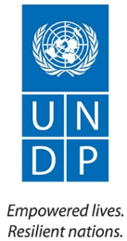
Economic Empowerment Programme (EEP)
2016 Quarterly Progress Report
(January - June, 2016)
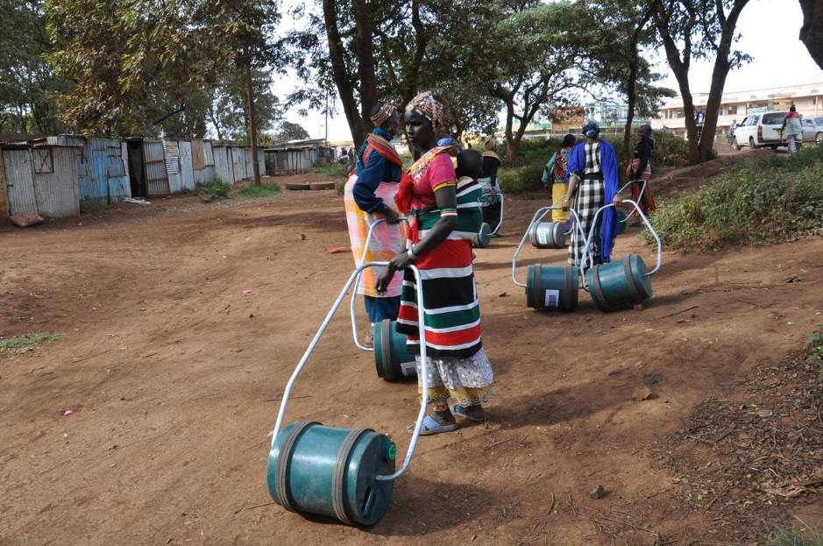

Project Summary | Country: Kenya  Project Duration: 2013 – 2018  Project Budget: US$ 5,390,000  Annual Budget: US$ 1,620,000  Donor Annual budget US$  UNDP (TRAC) 350,000  Cumulative expenditure (including for the reporting period):  Contact Persons: Boniface Kitili  Officer in Charge, IEG Unit  Tel. +254 20 7625169  Email: boniface.kitili@undp.org  Patrick Maingi  Programme Officer, IEG  Tel. +254 20 7624472  Email: patrick.maingi@undp.org
Responsible Parties:
IP: Ministry of Devolution and Planning

RPs: MoALF, MoEST, MoITC, MSEA, NITA, KenInvest, KNCCI, KEPSA, YEDF, HFF, KAM

Table of Contents
Acronyms 3
1. Executive Summary 4
2. Progress Towards Development Results 6
3. Gender Development Results 8
4. Targeting, sustainability of results, strengthening national capacities and South-South and Triangular Cooperation 9
5. Partnerships 10
6. Monitoring and Evaluation 11
7. Knowledge management 11
8. Challenges/Issues 11
9. Lessons Learnt and Way Forward 11
10. Risks and Mitigation Measures 12
11. Financial Summary 13

Acronyms

AGPO | Access to Government Procurement Opportunities
ASALs | Arid and Semi-Arid Lands
BCtA | Business Call to Action
BSED | Business Skills and Enterprise Development
CBDC | County Business Development Centres
CEC | County Executive Committee
DAO | Delivering As One
EEP | Economic Empowerment Programme
HACT | Harmonized Approach to Cash Transfers
HFF | Housing Finance Foundation
KAM | Kenya Association of Manufacturers
KenInvest | Kenya Investment Authority
KEPSA | Kenya Private Sector Alliance
KNCCI | Kenya Nat. Chamber of Commerce & Industry
MoALF | Ministry of Agriculture, Livestock and Fisheries
MoDP | Ministry of Devolution and Planning
MoEST | Ministry of Education, Science and Technology
MoITC | Ministry of Industry, Trade and Cooperatives
MSEA | Micro and Small Enterprise Authority
MSMEs | Micro, Small and Medium-size Enterprises
NITA | National Industrial Training Authority
NIP | National Investment Policy
OSIC | One Stop Investment Centre
ROTB | Roll Out The Barrel
TRAC | Thematic Resources Allocated from Core
UNCT | United Nations Country Team
UNDAF | United Nations Development Assistance Framework
UNDP | United Nations Development Programme
YEDF | Youth Enterprise Development Fund

Executive Summary

The Economic Empowerment Programme (EEP) was designed in 2013 by different public and private partners, including the Ministry of Devolution and Planning, the Ministry of Industrialization. Through EEP, UNDP has committed to support the Government’s aspiration of enhancing job creation. This will be supported by facilitating access to business development services, which will include vocational and entrepreneurial skills training with a deliberate support to agro-entrepreneurship, access to markets, incubation, industrial and business attachment, mentorship and advocacy for ease of access to credit services. To support these initiatives, this programme will support the establishment and operationalization of County Business Development Centres (CBDC), also referred to as “County Biashara Centres”), which will act as the focal one stop centres for enhanced productivity, technology transfer, business incubation, and provision of business development services for the youth, women and MSEs in general.

The overall outcomes of the programme are:
- enhance and mainstream inclusiveness of the poor and vulnerable in institutional and policy frameworks and private sector participation in job-rich and pro-poor growth; and
- empower the poor and vulnerable (in particular women and youth) as economic agents

EEP contributes to the UN Development Assistance Framework (UNDAF) Strategic Result Area 3 on “Inclusive and Sustainable Economic Growth” which states that “By 2030, Kenya becomes an industrialized middle income country with a modern, equitable, diversified and 24-hour Green Economy in which growth is inclusive and achieves sustainable development, trade is modernized, balanced, competitive and regionally-integrated, and employment matches demand, is stable, SME-driven, decent, accessible (particularly to youth, women and vulnerable groups) and Human Rights compliant”. Specifically, the programme is also contributing to the UNDAF Outcome 3.2 on “Productive Sectors and Trade” which states that “By 2018, Productive sectors (finance, agriculture, tourism, manufacturing, extractive industry), trade and their value-chains are private and SME driven, sustainable, diversified, technologically innovative, commercially orientated and competitive on national, regional and global markets”. EEP contributes to the UNDP Kenya Country Programme Document (CPD) Outcome 2 on “Productive Sectors and Trade”.

As of June 2016, the programme continued to support “inclusive and sustainable economic growth in Kenya by working to ensure that the business environment for Micro, Small and Medium Enterprises (MSMEs) is improved and ensure that the inclusion of youth and women is enhanced in Kenya. To achieve this, EEP is supporting the Kenya Investment Authority (KenInvest) to develop a One-Stop Investment Centre in Nairobi and also develop a draft National Investment Policy. EEP has worked with the lead private sector companies, under their umbrella organization, the Kenya Private Sector Alliance (KEPSA) to support youth employment through placements, internships and attachment.

Under the outcome on economic empowerment for women and youth, the programme has supported the establishment of four (4) County Business Development centres, now commonly referred to as Biashara Centres. Biashara Centres act as a one-stop-shop facilities for enterprise development and SMEs support centre in the Counties and are jointly funded jointly by UNDP and the County Governments. UNDP continued supporting the implementation of the Small and Micro Enterprises (SME) Strategic Plan 2013-2017 as envisioned by Micro and Small Enterprises Authority (MSEA); specifically, a revised SME Handbook – setting clear guidelines for SME regulation – was finalized and launched. The MSEA’s SME Handbook presents informed opportunities for SME development in Kenya.

The main challenge in EEP is attracting funds to support these initiatives. So far, EEP has been relying on TRAC funds from UNDP, with minimal support from the respective County Governments. The programme staff are working hard to attract funding from bilateral and multilateral donors.

The total budget for this year is US$ 300,000, with a cumulative expenditure of US$ 222,219 so far, which represents an 81% delivery rate.

Progress Towards Development Results

UNDAF Outcome 3: Inclusive and Sustainable Economic Growth
By 2030, Kenya becomes an industrialized middle income country with a modern, equitable, diversified and 24-hour Green Economy in which growth is inclusive and achieves sustainable development, trade is modernized, balanced, competitive and regionally-integrated, and employment matches demand, is stable, SME-driven, decent, accessible (particularly to youth, women and vulnerable groups) and Human Rights compliant.

UNDAF Outcome 3.2 / CPD Outcome 2: Productive Sectors and Trade
By 2018, Productive sectors (finance, agriculture, tourism, manufacturing, extractive industry), trade and their value-chains are private and SME driven, sustainable, diversified, technologically innovative, commercially orientated and competitive on national, regional and global markets

CPD Outcome Target | Summary achievement to date | Status
Business Environment for Small and Micro enterprises improved, economic inclusion ensured; public private collaboration is enhanced. | - Supported a 2-day workshop with MSEA and CECs to discuss SME coordination in the counties  - Provided technical and financial support towards the development of a National Investment Policy (NIP)  - Conducted various training sessions in various counties on business skills and enterprise development  - SME Handbook has been distributed through the National and County Government information centres, various apex Business Member Organizations in the Micro, Small and Medium Enterprises (MSMEs)  - In partnership with KEPSA, organized a forum with private sector to support Youth Employment and Skills Building in Kenya  - In our endeavour to support initiatives that promote inclusive business approaches in Kenya, EEP partnered with PSP4H to organize a joint event and launched the report on the use of technology / mobile platforms to increase access to health care in Kenya | Ongoing
The poor and the vulnerable are empowered as economic agents with strengthened capacities and opportunities to engage in and benefit from the market systems and business ecosystems | - Supported the establishment of two more CBDCs in Marsabit and Turkana  - Existing CBDCs continued to support youth enterprises, improve employability and encourage productivity at the counties  - Trained 2000 plus youth on AGPO
Overall Status |  | Ongoing

Relevant CPD Output 2.1: Public and Private sectors at national and devolved levels are technically capacitated to formulate and utilize equitable evidence based business friendly policies and frameworks that are human-rights based, gender sensitive and stimulate inclusive and environmentally sustainable economic growth.
CPD output targets | Summary achievement to date | Status
5 policies by 2018 | - National Investment Policy  - National Youth Empowerment Strategy | Ongoing
Overall status |  | Ongoing

Relevant CPD Output 2.3: Public and private sectors are technically, technologically and financially capacitated to develop and adapt responsible and sustainable enterprises that are resources efficient and innovative
CPD output targets | Summary achievement to date | Status
20 CBDCs by 2018 | - 4 CBDCs established by June 2018 | Ongoing
Overall status |  | Ongoing

Project Output 1: Business environment for Micro and Small Enterprises (MSEs) sector development is improved; the economic inclusion of youth and women is ensured; and public private collaboration is enhanced.
Annual Output Target (2016)  (AWP indicator targets) | Summary achievement during the quarter (cumulative, Qtr 1 and Qtr 2) | Status:
Capacity of public and private institutions at national and county levels strengthened to promote SME- driven private sector development through formulating and implementing policies, programs and strategies. | - Supported MSEA to develop an MSE Coordination and Harmonization Framework for Counties.  - Supported KenInvest in the process of developing a NIP  - Supported the development of the NYES  - Supported the finalization of the YP / VTCs Strategy | Ongoing
National, county and private sector actors enabled to establish partnership, create inclusive economic opportunities and transform productive capacities for sustainable jobs creation and improve livelihoods. | - Carried out AGPO training in Marsabit, Turkana, Kwale, Taita Taveta and Nakuru counties  - With BCtA and KEPSA, organized a consultative forum with the private sector, to make commitments for youth employment  - Organise joint event and launch of report with PSP4H on Health Sector – Use of technology / mobile platforms to increase access to health care in Kenya | Ongoing
Overall status |  | Ongoing

Project Output 2: The poor and vulnerable (in particular women and youth) are empowered as economic agents with strengthened capabilities and opportunities to engage in, benefit from and shape the market systems they are interacting in.
Annual Output Target (2016)  (AWP indicator targets) | Summary achievement during the quarter (cumulative, Qtr 1 and Qtr 2) | Status:
One stop County Business Development Centres established and strengthened to enhance service delivery for MSEs in counties. | - Taita Taveta CBDC established  - Kwale CBDC established  - Marsabit CBDC established  - Turkana CBDC established | Ongoing
Youth and women accessing market driven vocational / entrepreneurial skills increased and are employable and National Occupations Frameworks in place. | - Supported NITA to edit and print competency standards and progression pathways for 5 sectors  - Facilitated the training of thirty (30) youths in BSED in Taita Taveta County  - Facilitated the training of thirty-six (36, 14 female) youths in BSED in Kwale County  - Distribute new technology water barrels to women in rural communities – Turkana (300), Marsabit (150)  - Under the AFIM / ASDP project, undertook a quick feasibility study for agro-value chains in Kwale and Taita Taveta counties. | Ongoing
Overall status |  | Ongoing

Gender Development Results

Gender results | Evidence
Gender result 1: In partnership with Roll Out the Barrel (ROTB), a UK based company, the programme has specifically targeted women in arid and semi-arid areas (ASAL) and distributed 800 new technology water barrels to women in rural communities | Evidence 1: EEP reports and photos
Gender result 1: Facilitated the training of thirty-six (36, 14 female) youths in BSED in Kwale County | Evidence 1: EEP reports and photos

Targeting, sustainability of results, strengthening national capacities and South-South and Triangular Cooperation

  - Targeting
Target groups | Needs addressed | Evidence
Youth | Youth empowerment  Enterprise development  Skills development | EEP reports and photos  County Government Reports
Women | Women empowerment  Enterprise development  Skills development | EEP reports and photos  County Government Reports
PLWDs | Empowerment of PLWDs  Enterprise development  Skills development | EEP reports and photos  County Government Reports

  - Sustainability
Results achieved | Sustainability
- Establishment of a One Stop Investment Centre (OSIC) | The Government of Kenya envisions a One Stop Investment Centre (OSIC) investors; the Centres are meant to help local and foreign investors with regulatory approvals and finding partners and markets, as well as ease the process of accessing Government services. An OSIC would have comprehensive information on all the country’s economic sectors and serve as incubators foreign businesses as the investors look for offices in the country.
- Development of National Youth Empowerment Strategy (NYES) | NYES provides a nationwide policy framework for youth engagement and empowerment; setting the phase for a coordinated and integrated approach to prioritization, implementation, monitoring and review of youth interventions in Kenya.
- Establishment of County Business Development Centres (CBDC) | The establishment of CBDCs provides an avenue for increasing access to BDS and linkages thus providing an opportunity for empowering the poor and vulnerable as economic agents thus improving the livelihoods.

  - Strengthening National Capacity
Results achieved | Institution | National capacity strengthened
- Harmonized Approach to Cash Transfers (HACT) training | MSEA, NITA, MoDP | UNDP Kenya carried a Harmonized Approach to Cash Transfers (HACT) training for all its partners, this is to ensure that all responsible parties understand and implement sound financial managements guidelines. Capacity building remains an ongoing activity for all partners.

  - South to South and Triangular Cooperation
Country | Type of cooperation
- N/A | N/A

Partnerships

In order to achieve the target results, EEP has continued to work with both public and private sector partners. In the public sector, UNDP works with the Ministry of Agriculture, Livestock and Fisheries (MoALF), the Ministry of Education, Science and Technology (MoEST), the Ministry of Industry, Trade and Cooperatives (MoITC), the Micro and Small Enterprise Authority (MSEA), the National Industrial Training Authority (NITA), the Kenya Investment Authority (KenInvest), the Youth Enterprise Development Fund (YEDF) and various County Governments.

In the private sector, the programme has established sound partnerships with various private sector and / or umbrella organizations like the Housing Finance Foundation (HFF), the Kenya Association of Manufacturers (KAM), the Kenya Nat. Chamber of Commerce & Industry (KNCCI) and the Kenya Private Sector Alliance (KEPSA).

Monitoring and Evaluation

M&E activities conducted during the quarter:
M&E activity | Key outcomes/ observation | Recommendation | Action taken
Monitoring Visits | One visit is planned to each of the CBDCs per year | Enhanced management of CBDCs | None

Knowledge management

Knowledge products completed/published during the reporting period:
Title, author, date | Link | Evidence
n/a | n/a | n/a

Challenges/Issues

The main challenge in EEP is attracting funds to support these initiatives. So far, EEP has been relying on TRAC funds from UNDP, with minimal support from the respective County Governments. The programme staff are working hard to attract funding from bilateral and multilateral donors.

Lessons Learnt and Way Forward

We must continue to genuinely embrace ‘DaO’ and deepen our partnerships with UNCT agencies so that through the UNDAF Architecture we can achieve UN Reform.

During the BSED training in Kwale County, it became clear that religion is a key issue in most of the Kenyan Communities. Kwale is a predominantly Muslim community, and the trainees would leave an ongoing training session to go for prayers. It is important for any trainer to be aware of this fact and create time for personal prayer in the training programme.

Risks and Mitigation Measures

Risks | Mitigation Measures
Low Level of Programme Funding | Continuous engagement with potential donors.

Financial Summary

Outputs / Activity Result |  | Current Annual Budget (US$)  (Jan – Dec 2015) | Total Expenditure (Reporting Period)  Skip this column for annual reporting | Cumulative Expenditures | % Expenditure  (Cumulative)
 |  | A | B | D | D/A*100
Output 1: Business environment for Micro and Small Enterprises (MSEs) sector development is improved; the economic inclusion of youth and women is ensured; and public private collaboration is enhanced.
Activity Result 1 | Capacity of public and private institutions at national and county levels strengthened to promote SME- driven private sector development through formulating and implementing policies, programs and strategies. | 35,000.00 | - | 0.00 | -
Activity Result 2 | National, county and private sector actors enable to establish partnership, create inclusive economic opportunities and transform productive capacities for sustainable jobs creation and improve livelihoods. | 35,000.00 | - | 212.00 | -
Output 1 Sub-total |  | 70,000.00 |  | 69,788.00 | 1%
Output 2: The poor and vulnerable (in particular women and youth) are empowered as economic agents with strengthened capabilities and opportunities to engage in, benefit from and shape the market systems they are interacting in.
Activity Result 1 | One stop county business development centres established and strengthened to enhance service delivery for MSEs in counties. | 50,000.00 | - | 73,685.70 | -
Activity Result 2 | Youth and women accessing market driven vocational/entrepreneurial skills increased and are employable and National Occupations Frameworks in place. | 80,815.00 | - | 33,652.41 | -
Output 2 Sub-total |  | 130,815.00 |  | 97,096.11 | 91%
Output 3: Coordination mechanisms for project implementation operationalized and strengthened.
Activity Result 1 | Programme Management | 99,185.00 | - | 124,910.00 | -
Output 3 Sub-total |  | 99,185.00 | - | 124,910.00 | 126%
Grand total |  | 300,000.00 | - | 222,219.00 | 81%

